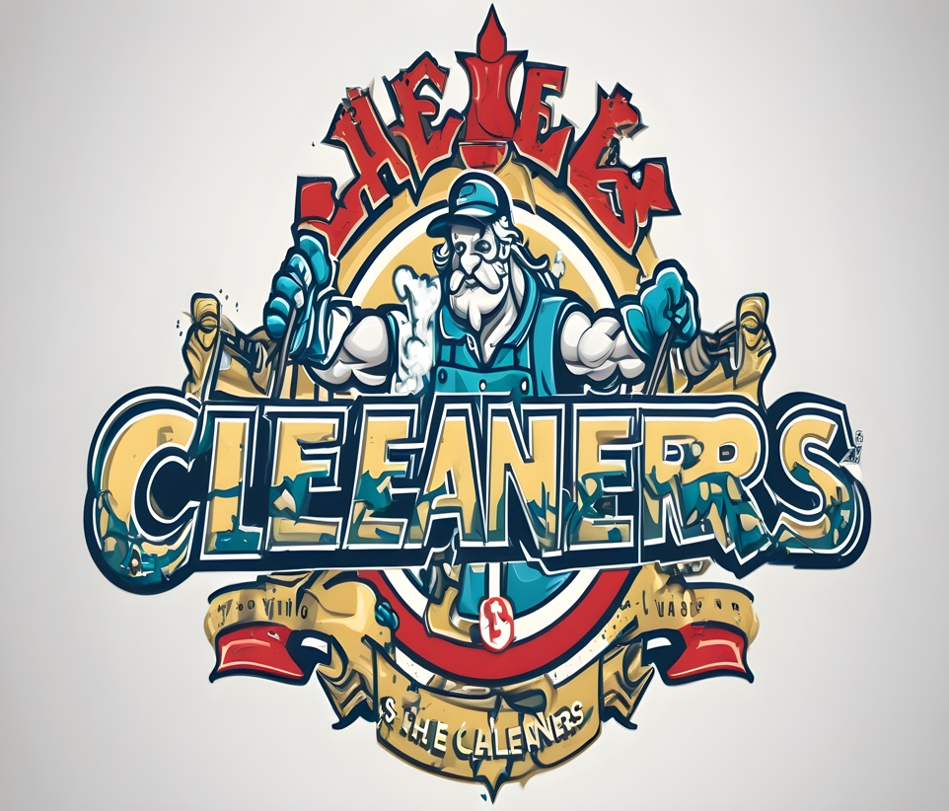

**The Cleaners**

**Mobile Cleaning Service**

*“Everything is Cleaner with The Cleaners!”*

Plan of product/service:

The Cleaners are a cleaning service that cleans and service people's house. We bring essential cleaning supplies such as dilute cleaner, broom & mop, cleaning wipes, and rags. The PPE we will provide is a KN-95 mask, gloves, and eyewear for Team Members. We will supply the employee with all the cleaning supplies at our docking center. This could be as a small parking lot, where we store and dock for our vans. Employee drivers will also be supplied with company cards with only $500 for Gas and food usage. To avoid misusage Weekly auditing of the amount that has been used on the card. Employees would use company phones to keep track of each client to connect the employer and employee Fast, Efficiently, and Effectively. This can be supplied through a business account with Apple or any other network provider to track and secure phones. The customer will pay the worker via Mobile POS that can connect with the phones they are using via a charging port.

Business philosophy/purpose:

We Promise to provide trustworthy reliable, high-quality cleaning for our customers while providing an efficient and transparent customer experience.

Cost of the Operations:

PPE Cost:

Van Storage: $4,824

Van lease: $9.900

Cleaning supplies: $1,928.40

Transportation: $6,000

SGA Cost:

Employee Wage: $10,000

Marketing & Advertisement: $5,000

Administrative Salary: $15,000

Web Development cost:

Website Development: $15,000

Total Cost: $57,762

Pricing & Buyers:

per square foot: .10 cents

Average size house (1,150 Sq Ft) in SF: $103.99

Number of buyers per month: 10

Total number of Buyers:120

Profit per month: 1,039.90

Total Profit: $12,478.80

Target Audience:

Region/State: Bay Area

Age: 55+

Gender: Male & Female

Income Level/Social Class: Middle Class/ High Class

Competition:

The competition consists of the companies “AllBetter”, “Handy”, “MaidsApp”, “Tidy”, and “Housecall Pro”. Allbetter is a Mobile app that lets you find contractors, cleaning services, painters, etc. Many people see their app and usage as something easy to use (easy customer interface), reliable customer service, and offer on-demand jobs for those who need them. Handy is strictly cleaning in which you can request different times for cleaning such as one-time and reoccurring such as weekly, bi-weekly, and monthly. Pros of this service are the easy-to-use interface and recurring cleaning option. Cons are the lack of customer service, leading to a sense of unreliability and low ratings. MaidsApp imitates Handy but offers online videos and tutorials to help clean hard-to-clean spaces and stains. Tidy is an online cleaning service that focuses more on customer service. They do this by offering a tidy satisfaction guarantee in which if the customer doesn’t like they receive future tidy for future cleanings. Housecall Pro is an all-in-one cleaning app that connects you with a home cleaning community. You have complete control over scheduling, payments, and more. It's known for being the most affordable and straightforward app to use. Con is that they are a subscription service.

We are better due to our mobile app design for a straightforward and user-friendly interface on our website and app. This comes from the uniform feel of our company, and great customer service. The customer satisfaction guarantee makes sure the customer never leaves unhappy. If standards aren’t met we will refund your money unless this feature is abused. Our website and app will be safe and encrypted for transactions. This all led through use and no contractors as we employ the people who clean.

Startup Cost:

What I am asking for is 100,000 and 15% of the total company. This is because not only can we house regular everyday people, but also obtain government contracts to clean up facilities and public spaces. Our high outreach and high growth potential in this day of age. As cleaning can be a hassle and take away from exploring the ever-expanding world.

2-5 Year Plan:

I see my company in 2 years making real growth growing almost 125%, This will be accompanied by re-investing the money into our company R&D to create a cleaning solution that is an all-purpose cleaning agent where people can buy from our site and our cleaners. This will be later adopted by Amazon while marketing our cleaner using our employees and online ads. We will start our launch in the Bay Area at first and expand out from California and later expand our way out. Stay focused on branding to create a community of people and connections for an on-demand feature for those outside the area. We can use this influence to ask for cleaning contracts for facilities such as apartment complexes and living spaces. In the next 5 years, the company will focus on employees and gathering more employees by doing job postings to accompany the increase in demand as well as more vans. Growth and sustainability within our niche and community would be the next plan. Re-investing in marketing and R&D for more products and campaign advertisements.

Why should the sharks invest in your company?

I believe the Sharks should invest because not only our growth potential but also with the right specialists and connections this company takeoff and grow. Although we are new we have a market for our company and also with the ever-growing world. This makes it harder for hard-working people who just need a helping hand. This is also a low-cost business as most costs can be cut with the right suppliers. Marketing and the release of our products to the cleaning market with an effective marketing campaign. This can create a sense of demand as our brand would steadily increase, using the community we built to hire people for that increase. I say with your guy's help operations costs would be cut and more management would allow for a bigger increase in customer demand.